Figures
Figure 1. The habitat domain concept, where habitat domain is defined as the spatial extent to which a microhabitat is used by a species, applied to intertidal boulder fields. Each species’ habitat domain is depicted as vertical stretched circles. Microhabitat is defined by vertical zonation on the shore. Prey, the mussel Mytilus californianus, recruit to both horizontal and vertical surfaces in boulder fields: they have a broad habitat domain. Mussel predators, the sea star Pisaster ochraceus, and the rock crabs Cancer productus and Romaleon antennarium use different portions of the available microhabitat and so have narrow habitat domains on low horizontal and vertical surfaces, respectively. Mussels overlap with both predators on low horizontal and vertical surfaces, and are limited to higher vertical surfaces by these predators. The predators overlap on low horizontal surfaces, but Pisaster is segregated from rock crabs on vertical surfaces.

Figure 2. Mussel recruitment rates from June to September 2019 at each of the 3 study sites arranged from the northernmost site on the left to the southernmost site on the right.

Figure 3. Mean Pisaster ochraceus and rock crab (R. antennarium) density (± SE) in June and August 2019 at each of the 3 study sites arranged from the northernmost site on the left to the southernmost site on the right.

Figure 4. Interaction between the effects of Pisaster ochraceus and rock crabs (R. antennarium) on A) the mean proportion of live mussels (± SE) during 14 d of the mussel transplant experiment and B) the mussel survival rates (ln(M_{t}/M₀)/d) at the end of the experiment. Data are the mean slopes and standard errors of regressions between the logarithm of the proportion of live mussels vs. time, computed separately on each of the five replicates.

Figure 5. Mean (A) per population or total interaction strengths (± SE); and (B) per capita interaction strengths (± SE) between mussels and predators in the absence and presence of each other.

Figure 6. Mean consumption rate of A) Pisaster ochraceus and B) rock crabs (R. antennarium) on mussels in the absence, chemical presence, and physical presence of each other during the laboratory feeding experiment. Error bars represent standard error.

Figure 7. The cumulative proportion (%) of time in which Pisaster ochraceus exhibited each of the five recorded behaviors in A) the absence, B) chemical presence, and C) physical presence of rock crabs (R. antennarium) during the laboratory feeding experiment.

Figure 1
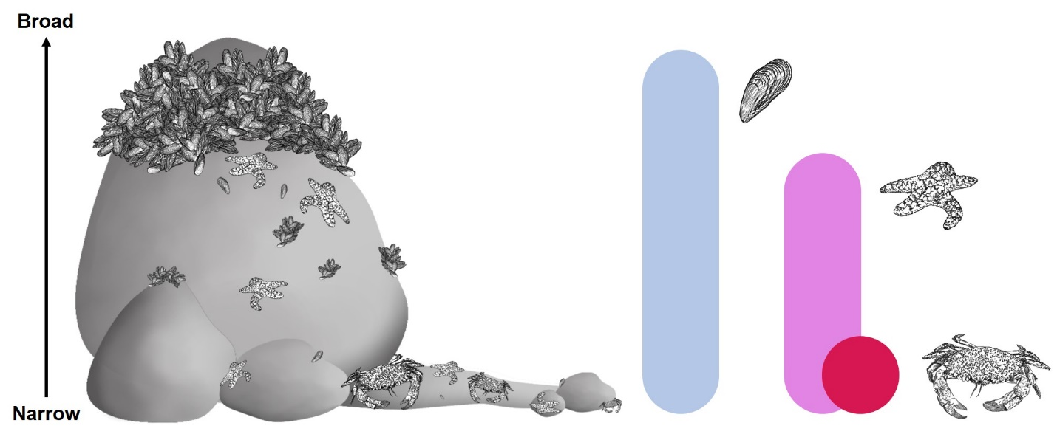

Figure 2


Figure 3


Figure 4
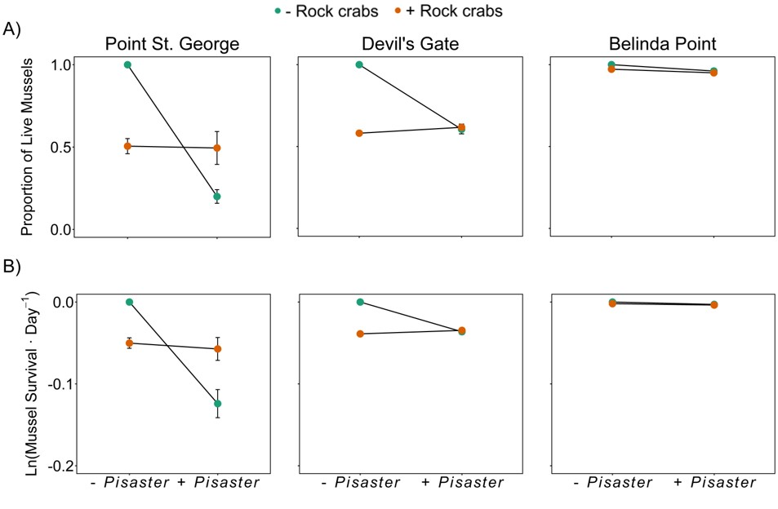

Figure 5



Figure 6

Figure 7

Supplementary Material


